When posting your position on a job board outside the ATS you are able to add in the job page or application page URL directing candidates to your apply process and change the apply source to track where you candidates are applying from.
- Log into the ATS and click on the job you are posting
- On the right had side under Job Information you will see External Links
- Click the Application Page link if you would like candidates to go directly to the application without viewing the job description. (Note: you can use the job page as well if you want applicants to view the job description again before applying)
- Once clicking on the link the application page will appear.

Application Page View
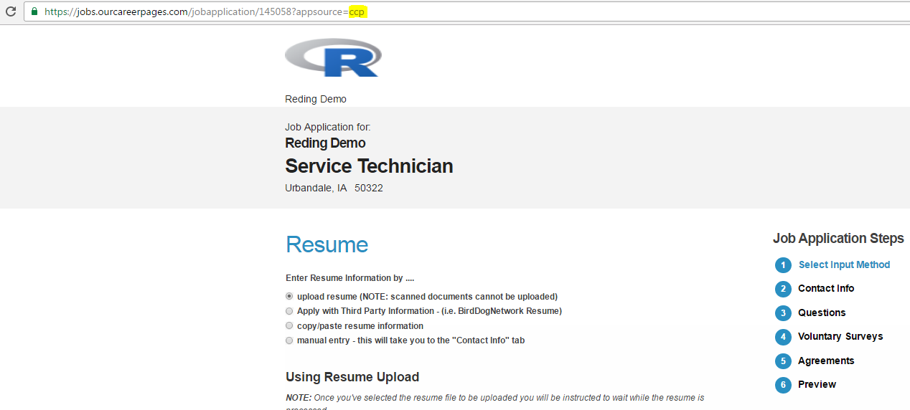

- Highlighted in yellow above is the CCP code.
  - Changing this will allow you to track where your applicant applied from (this is optional but helps with reporting)
(Example: if you are posting on Craigslist, change the CCP to Craigslist)
Example:
Before: https://jobs.ourcareerpages.com/jobapplication/145058?appsource=ccp
After: https://jobs.ourcareerpages.com/jobapplication/145058?appsource=Craigslist
- After changing the ccp code, copy the entire URL
- Paste the entire URL into the apply source on the job board you are posting your position
  - Instead of directing candidates to an email or another source, they will apply to your application and land in your job posting and candidate pool in the ATS
